A000-Asia-China-Hongshan-Pig Dragon-3500-2200 BCE

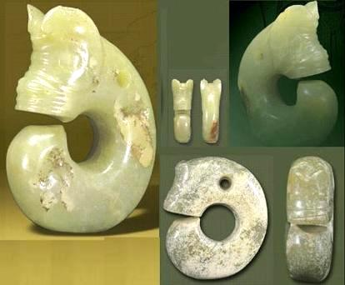

Left: a set of figures showing aspects of two pig dragons collected by the Palace Museum of Taipei.

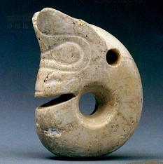

Right: one of two pig d﻿ragons found in a tomb at Niuheliang (the first was shown on the home page) more crudely crafted than other unearthed pig dragons

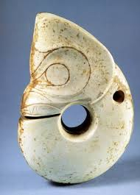

Pig bones were extensively found in the Hongshan residential sites and in some tombs, so that hog raising by Hongshan people appears common; the approachable, almost cute, appearances of the pig dragons indicate that pigs were not worshipped as sacred tri bal animals or totems, but were regarded more as friends of humans

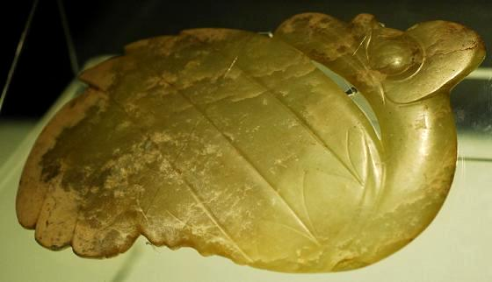

Birds are not as extensively represented in Hongshan jade objects as pig dragons, but

appear in more varieties; the figure on the left appears to represent a swan, unearthed in a Chengzishan tomb in 2003 together with several other jade items including the human figure shown below; the tomb's scale indicates its occupant's importance, as does the size and high workmanship of this item